## **IDEAS**

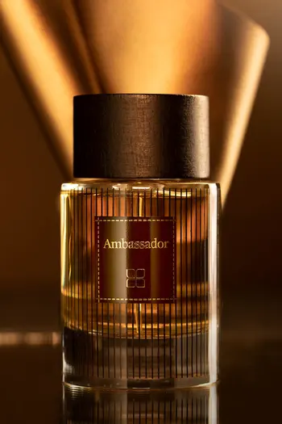

**Ambassador Perfume For Men**

** **

**PKR 4,290.00**

**Rich and seductive experience. The top notes open with mandarin, bergamot, and pepper. The heart notes exhale the beautiful essence of violet, orris leather suede. It ends with a lingering sense of power fully styrax, cypress, and incense.**

**Size: 100ml Bottle**